**Software Developer Course Assessment**

**Quantitative Assessment Practice**

**Course Name: Advanced Programming (Java)**

**Current Week: 13th September 2024**

**Submission date: 24th September 2024**

**Completion Info:**

1. How many hours did it take you to complete this assessment? (Please keep try to keep track of how many hours you have spent working on each individual part of this assessment as best you can - an estimation is fine; we just want a rough idea.)

1 Hour, 19 Minutes, 23 Seconds

1. What online resources you have used? (My lectures, YouTube, Stack overflow etc.)

None

1. Did you need to ask any of your friends in solving the problems. (If yes, please mention name of the friend. They must be amongst your class fellows.)

No

1. Did you need to ask questions to any of your instructors? If so, how many questions did you ask (or how many help sessions did you require)?

No. The materials were well covered in class and the ***Week2* *practice problems*** provided well enough practice to successfully complete this assessment.

1. Rate (subjectively) the difficulty of each question from your own perspective, and whether you feel confident that you can solve a similar but different problem requiring some of the same techniques in the future now that you’ve completed this one.

The entire assessment was straightforward and well-guided. The materials closely followed what we learned in class and covered similar concepts from previous semesters, so the assessment didn't take too long to complete. I am confident that I could solve a similar problem using the same techniques, and I am certain this knowledge will be useful in the future.

Q1 Proof of work – Account

Q2 Proof of work - Date

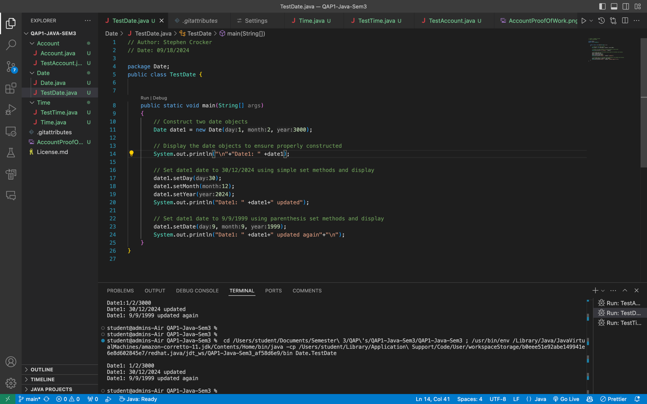

Q3 Proof of work - Time

